
Procedure 2025

ArcelorMittal Building Solutions France Procedure 1.1.1.11

CREDIT SYNCHRONIZATION

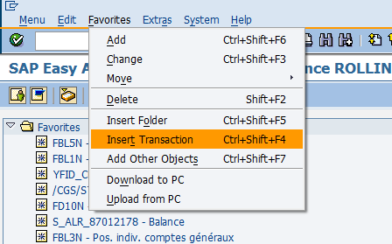
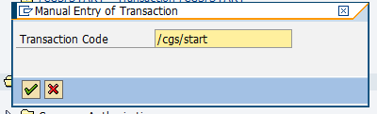

- Log on to SAP, specifying EN (English) as the working language.
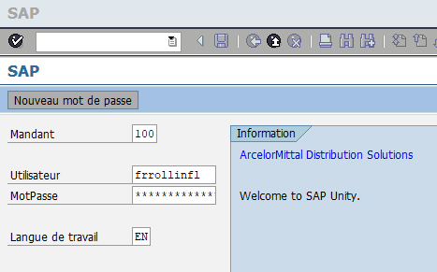

- Select CGS/START transaction
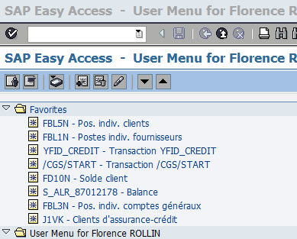

If this transaction is not in your list of favorites, you will need to add it. To do this, it
Simply type the name of the transaction in "Favorites / Insert Transaction" and confirm:

- Search for the customer using his SAP code, then press ENTER:
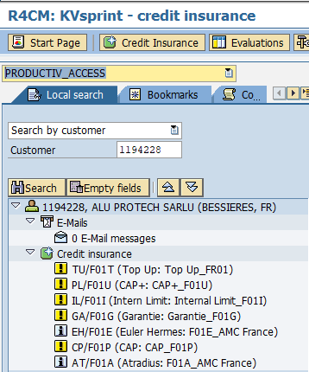

- Select the credit line to be synchronized by double-clicking on it
(always for entity F01 = AMC France)

Atradius :
Euler / ALLIANZ :
CAP :
CAP+ :
Internal:
Captive:
Third-party warranty:

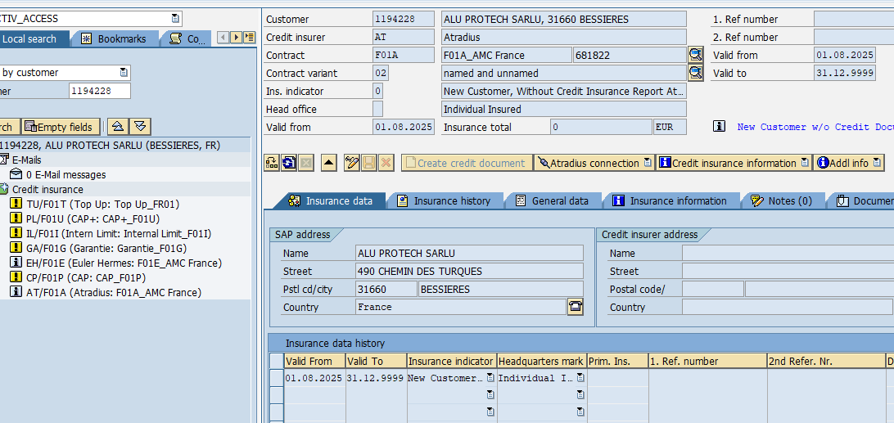

- Click on the pencil
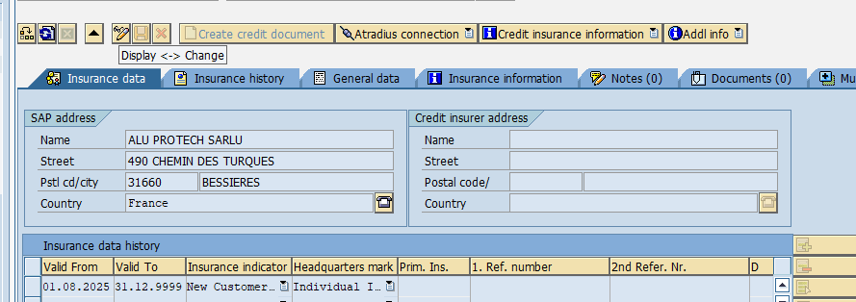


- In the "Insurance indicator" column, select "Named insurance".
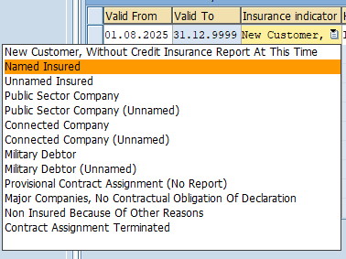

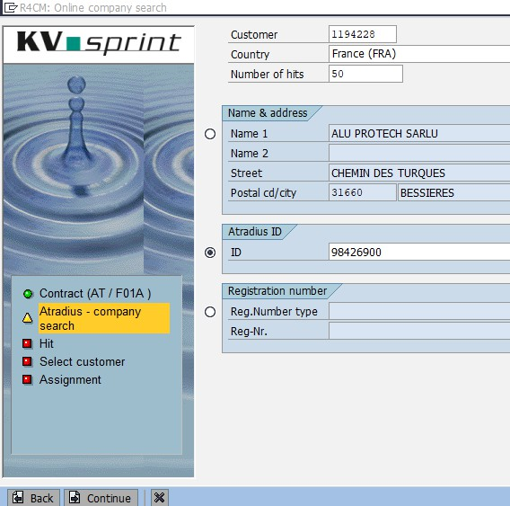
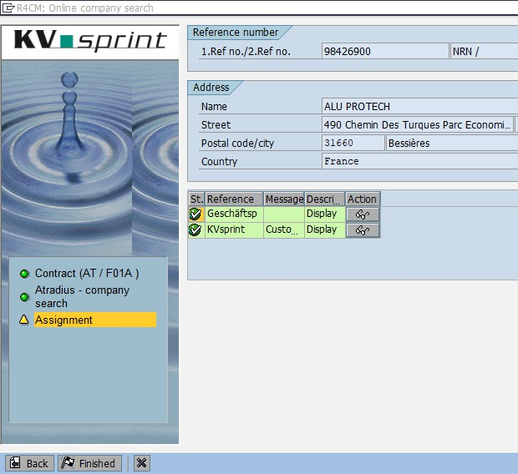
- Make the insurance connection by clicking on Atradius connection (or EH connection for EULER, the process will be the same)
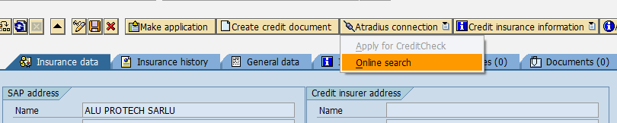

Enter the Atradius (or Euler) code in the ID box after ticking it, then click on
"Continue:

The system searches for the buyer and displays the data found. If the data match,
click on "Finished

- Enter credit data
Click on "Create credit document", then enter the date on which the credit was obtained in the
window and click on "Okay":
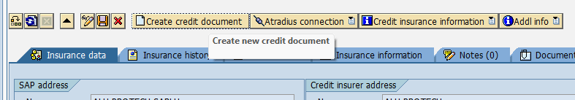
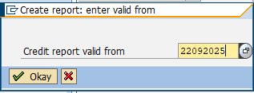

The page below opens, where you can enter the amount of credit granted as well as
its validity date.

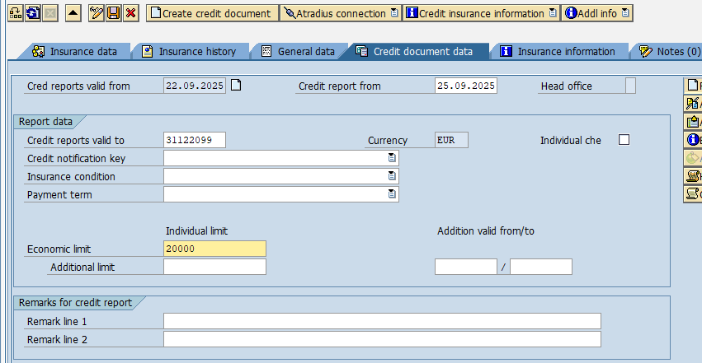


For main policy applications (F01A and F01E) where credits are granted for an indefinite period, the date 31/12/2099 must be entered (do not include a "." or "/" in the date).
For requests with an end date (F01P, F01U, F01T, F01I and F01G), the authorized end date must be entered.
Then save by clicking on the diskette to the right of the pencil.

- Check

After saving the data, the logo with the grey "i" becomes a small green square and the amount is completed.
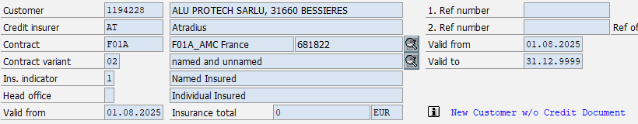
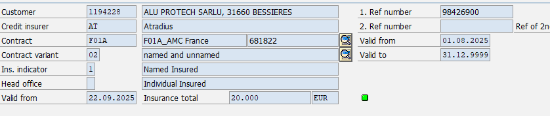

In the list of different credit coverages on the left, the line also changes to green with the small green square:
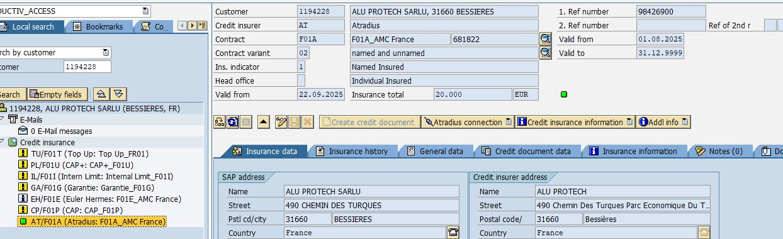

You can view your credit history by clicking on "Insurance History":
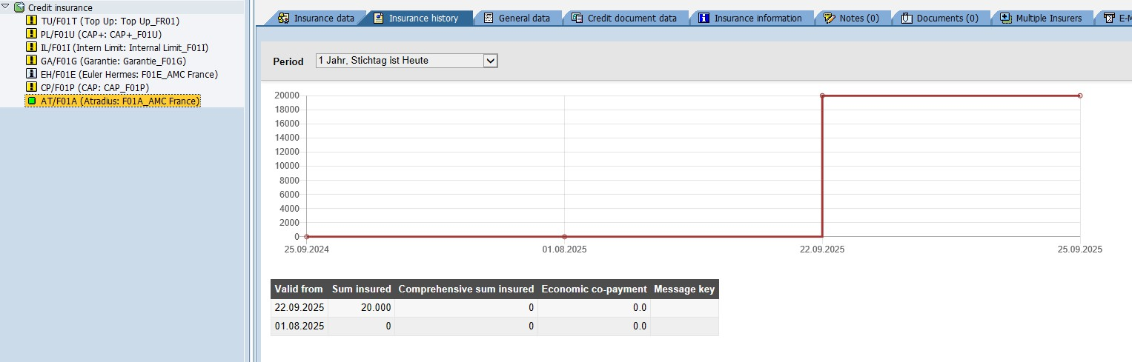

Add a cover line
Occasionally, a credit line may be missing from the list of coverages:
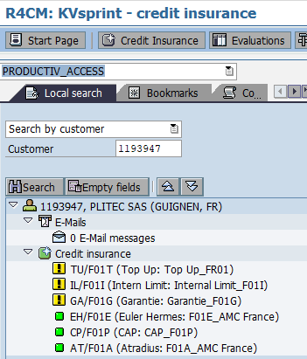

Here, the CAP+ line is missing, so you need to add it manually by clicking on "Credit Insurance" and selecting "Create customer" to reach this screen:

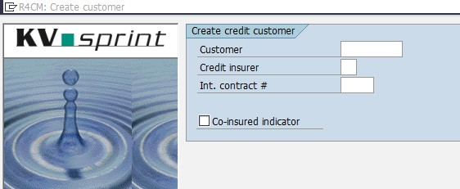

Customer = SAP customer code Credit insurer =Insurance to be added
Int. Contract # = SAP insurance code

If you don't know the codes to complete, you can click on the magnifying glass to the right of the
box to display the list:
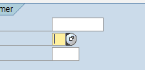
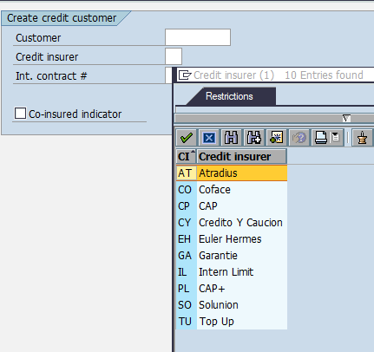


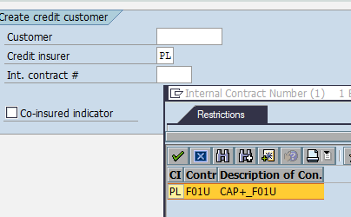
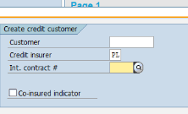


Then click on "Continue" at the bottom left of the window to arrive at the following screen:
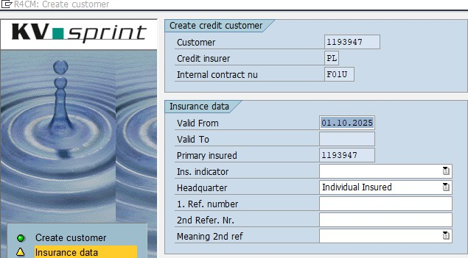

Complete "Ins indicator" with "Named Insured" and "1. Ref. number" with the customer's SAP code:
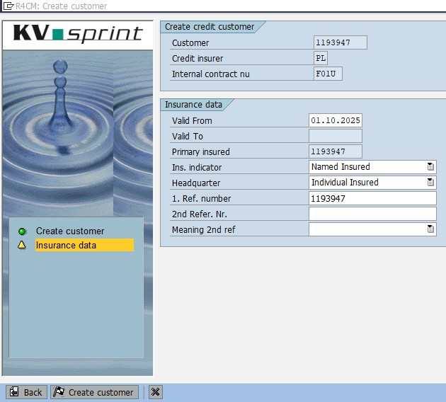

Then click on "Create customer".

Complete the CAP+ data (points H & I) and save with the diskette:
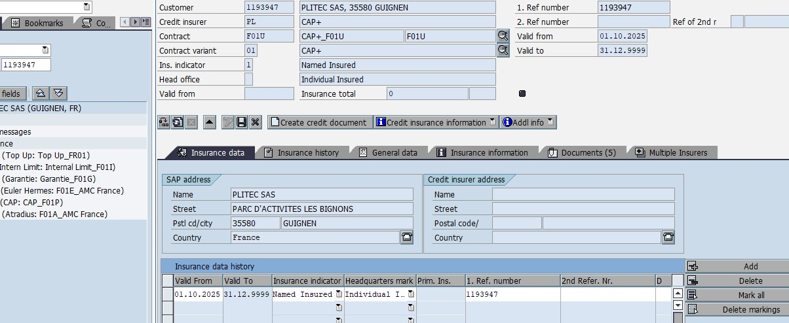

è The credit cover is now added to the customer list (refresh)

On: 03/11/2025
Procedure validated by : S.HERNANDEZ


